Biosphere जैवमंडल
“पृथ्वी का वह भाग जहाँ जीवन (plants, animals, microorganisms) पाया जाता है।”
इसमें शामिल हैं:
- भूमि (Land / Lithosphere)
- जल (Water / Hydrosphere)
- वायुमंडल का निचला हिस्सा (Air / Atmosphere)
जहाँ भी कोई जीवित चीज़ रह सकती है—वही Biosphere है
Biosphere पृथ्वी का वह संपूर्ण भाग है जहाँ जीवन पाया जाता है — यानी भूमि (lithosphere), जल (hydrosphere) और वायुमंडल (atmosphere) के वे सभी हिस्से जिनमें जीव रह सकते हैं।
“जहाँ-जहाँ जीवन है, वही Biosphere है।”

⭐ इसमें क्या-क्या शामिल है?
- Land (थल) के जीव – जंगल, रेगिस्तान, घासभूमि
- Water (जल) के जीव – नदियाँ, झीलें, महासागर
- Air (वायु) के जीव – उड़ने वाले जीव
- सब Ecosystems का कुल योग

Main Features of Biosphere (UPSC)
- यह जीवन का सबसे बड़ा स्तर है।
- इसमें सभी जीवित + निर्जीव कारक साथ मिलकर काम करते हैं।
- पूरी पृथ्वी पर फैला हुआ है।
- Biosphere तय सीमित क्षेत्र नहीं है—ऊँचाई और गहराई के अनुसार बदलता है।

Biosphere is the region of the earth where life can exist and grow. It is also known as the Ecosphere, which means constitution of all the ecosystems existing worldwide.

Components of Biosphere
Biosphere is made up of the parts of the earth where life exists not only human but also plant and animal life. It includes deep forests to grassland from ocean to rain forests from mountains to plains.
Biosphere consists of the following components :
- Lithosphere
- Atmosphere
- Hydrosphere
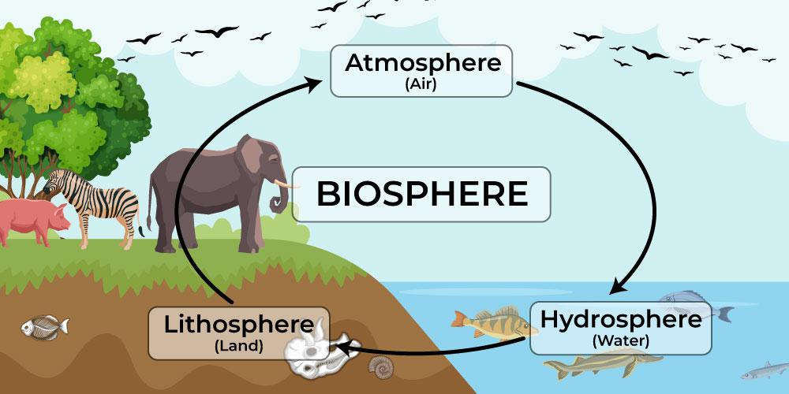

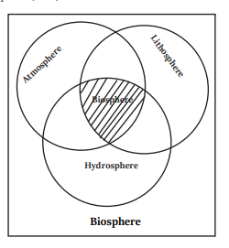

1. Lithosphere (स्थलमंडल का जीवित भाग)
- पृथ्वी की भूमि का वह हिस्सा जहाँ जीवन पाया जाता है।
- उदाहरण: जंगल, पहाड़, घास के मैदान, रेगिस्तान, कृषि भूमि।

2. Hydrosphere (जलमंडल का जीवित भाग)
- पृथ्वी के जल में जहाँ जीव पाए जाते हैं।
- उदाहरण:
  - समुद्र (Marine)
  - नदियाँ
  - झीलें
  - तालाब
  - जलदल (Wetlands)
  - महासागरों की सतह और कुछ गहराई तक

3. Atmosphere (वायुमंडल का जीवित भाग)
- वायुमंडल की troposphere का वह निचला हिस्सा जहाँ जीवित प्राणी रह सकते हैं।
- पक्षी, कीड़े, सूक्ष्म जीव, बीज आदि इस हवा वाले क्षेत्र में पाए जाते हैं।

वायुमंडल काकुछ किताबों में Biosphere को Terrestrial + Aquatic Biosphere के रूप में भी बताया जाता है:
- Terrestrial Biosphere → भूमि वाले ecosystems
- Aquatic Biosphere → जल वाले ecosystems

BIOSPHERE (जैवमंडल)

Biosphere क्या है?
Biosphere पृथ्वी का वह भाग है जहाँ जीवन संभव है और जीवित प्राणी पाए जाते हैं।
यह पृथ्वी की भूमि + जल + वायु तीनों में फैला हुआ है।

1. Biosphere के भाग (Components of Biosphere)
Biosphere दो मुख्य हिस्सों से मिलकर बना है:

(A) Biotic Components — जीव घटक
यह वे सभी जीवित चीजें हैं:
- Plants (पौधे)
- Animals (जानवर)
- Microorganisms (सूक्ष्म जीव)

(B) Abiotic Components — अजीव घटक
ये जीवन के लिए आवश्यक निर्जीव तत्व हैं:
- सूर्य का प्रकाश
- तापमान
- जल
- हवा
- मिट्टी
- खनिज

2. Biosphere की सीमा (Extent of Biosphere)
- वायुमंडल की troposphere का निचला भाग
- भूमि की सतह
- समुद्र की गहराई तक जहाँ जीवन संभव है
जहाँ भी कोई जीवित organism रह सकता है — वही Biosphere है।

3. Biosphere क्यों महत्वपूर्ण है?

(a) जीवन का समर्थन करता है
इसमें वह सब कुछ है जिसकी किसी जीव को जरूरत होती है—
खाद्य, पानी, हवा, आवास।

(b) Biogeochemical Cycles चलता है
Carbon, Nitrogen, Oxygen और Water cycle—
ये सभी Biosphere को जीवित बनाए रखते हैं।

(c) Biodiversity का आधार
पूरी पृथ्वी पर जितनी भी प्रजातियाँ हैं (plants + animals + microbes),
सब Biosphere में रहती हैं।

4. Biosphere और Ecosystem का संबंध
- Ecosystem छोटे-छोटे भाग होते हैं
(जैसे जंगल, नदी, तालाब)।
- Biosphere = सभी ecosystems का योग
यानी पृथ्वी का संपूर्ण जीवमंडल।

5. Biosphere के भीतर बड़े क्षेत्र — Biomes
Biosphere को बड़े-बड़े climatic regions में बाँटा गया है जिन्हें Biome कहते हैं।
जैसे:
- Tropical Rainforest
- Desert
- Grassland
- Tundra
- Marine
- Freshwater
हर Biome की अपनी जलवायु, पौधे, जानवर और मिट्टी होती है।

6. मानव का प्रभाव (Human Impact on Biosphere)
- वनों की कटाई
- प्रदूषण
- जलवायु परिवर्तन
- जैव विविधता की हानि
- मिट्टी का क्षरण
ये Biosphere के संतुलन को बिगाड़ते हैं।

7. संरक्षण (Conservation of Biosphere)
- National Parks
- Wildlife Sanctuaries
- Biosphere Reserves
- Pollution Control
- Sustainable Development

Biosphere पृथ्वी का वह क्षेत्र है जहाँ जीवन पाया जाता है।
यह भूमि, जल, और वायु के जीवित + अजीव घटकों का परस्पर क्रिया-कलाप (interaction) है जो पृथ्वी पर जीवन को संभव बनाता है।

Google
Top of Form

Bottom of Form

All

Videos

Images

News

Shopping

Maps

More
Tools
AI Overview
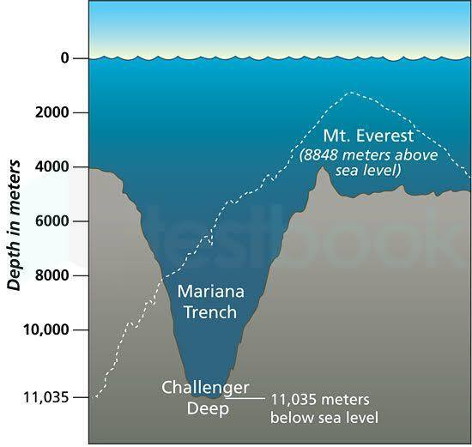

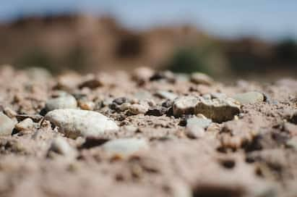
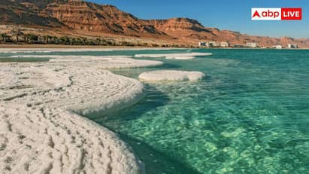
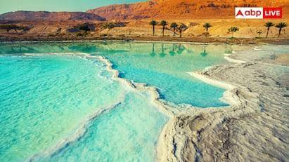
View all
जीवमंडल (Biosphere) पृथ्वी की वह पतली परत है जहाँ जीवन पाया जाता है, जो समुद्र की गहराइयों (लगभग 11 किमी नीचे) से लेकर वायुमंडल के ऊपरी हिस्सों (लगभग 20 किमी ऊपर) तक फैला हुआ है, जिसमें महासागरों की तलहटी और ऊँचे पहाड़ भी शामिल हैं, और यह लगभग 20 किलोमीटर मोटी परत बनाता है, हालाँकि अधिकांश जीवन समुद्र की सतह से कुछ सौ मीटर नीचे से लेकर कुछ किलोमीटर ऊपर तक सीमित है।
विस्तार की सीमाएँ:
- गहराई: यह समुद्र तल से लगभग 11 किलोमीटर (जैसे मारियाना ट्रेंच) नीचे तक जाता है, जहाँ सूक्ष्मजीव पाए जाते हैं।
- ऊँचाई: यह वायुमंडल में लगभग 20 किलोमीटर (या कुछ स्रोतों के अनुसार 10 किमी तक) ऊपर तक पहुँचता है, जहाँ पक्षी और सूक्ष्मजीव होते हैं।
मुख्य बातें:
- कुल मोटाई: जीवमंडल की औसत मोटाई लगभग 20 किलोमीटर है, जो पृथ्वी की सतह पर जीवन के अस्तित्व को दर्शाती है।
- जीवन का केंद्र: ज़्यादातर जीवन (पौधे, जानवर, सूक्ष्मजीव) समुद्र की सतह के आसपास (500 मीटर नीचे से 6 किमी ऊपर तक) केंद्रित है।
- गहरा जीवमंडल (Deep Biosphere): समुद्र तल के नीचे की चट्टानों और मिट्टी में भी जीवन होता है, जो जीवमंडल का एक महत्वपूर्ण हिस्सा है।

Top of Form
Bottom of Form

All

Videos

News

Images

Shopping

Web

More
Tools
AI Overview
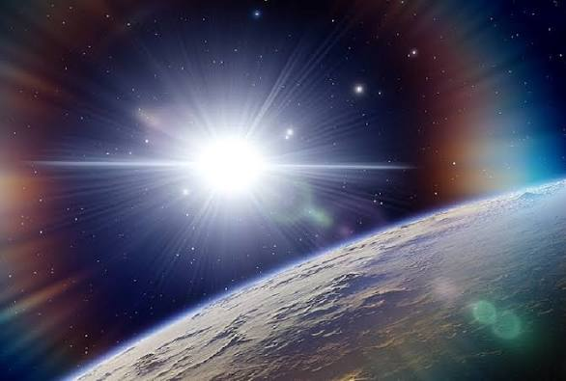
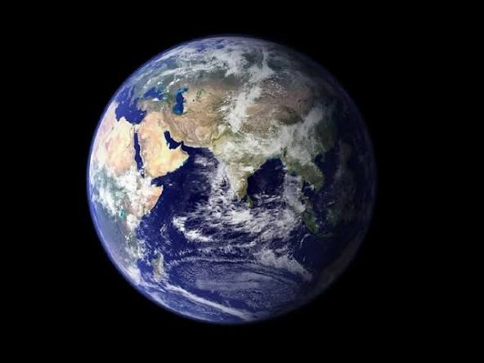
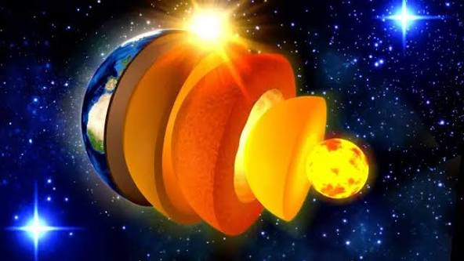
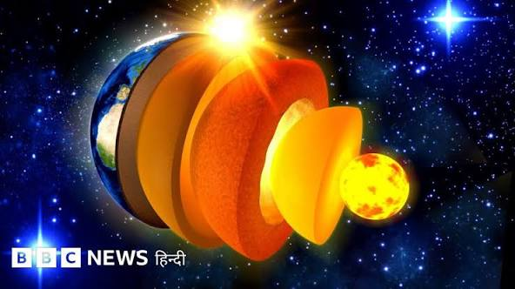
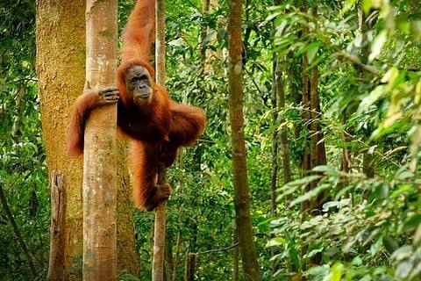
View all
हाँ, आपका कथन बिल्कुल सही है; जीवमंडल (Biosphere) पृथ्वी का वह हिस्सा है जहाँ जीवन मौजूद है, और जहाँ जीवन नहीं है, वह हिस्सा जीवमंडल का हिस्सा नहीं होता, क्योंकि जीवमंडल सभी जीवधारियों और उनके अजैविक पर्यावरण (जैसे भूमि, जल, वायु) के उस संकरे क्षेत्र को कहते हैं जहाँ जीवन संभव है और एक-दूसरे से जुड़े होते हैं।
बायोस्फीयर क्या है?
- यह पृथ्वी का वह क्षेत्र है जहाँ जीवन पाया जाता है, जिसमें स्थलमंडल (लिथोस्फीयर), जलमंडल (हाइड्रोस्फीयर) और वायुमंडल (एटमॉस्फीयर) के वे हिस्से शामिल हैं जो जीवन का समर्थन करते हैं।
- इसमें सभी जीव (मनुष्य, जानवर, पौधे, सूक्ष्मजीव) और उनके आसपास का वातावरण शामिल है, जो एक साथ मिलकर एक बड़ी पारिस्थितिकी तंत्र बनाते हैं।
जीवन के बिना क्या होता है?
- पृथ्वी के अंदरूनी हिस्से (जैसे कोर) और बहुत गहरे समुद्र तल जहाँ जीवन नहीं है, वे जीवमंडल का हिस्सा नहीं हैं, क्योंकि वे जीवन को बनाए रखने वाली प्रक्रियाओं में सीधे तौर पर शामिल नहीं हैं।
- जीवमंडल का मतलब ही 'जीवन का क्षेत्र' है, इसलिए जीवन के बिना कोई क्षेत्र जीवमंडल नहीं कहलाता।
- क्या जीवमंडल के बिना जीवन हो सकता है?
- उत्तर: यदि जीवमंडल लुप्त हो जाए, तो पृथ्वी पर जीवन का अंत हो जाएगा । पेड़-पौधे और जानवर मर जाएंगे, और पृथ्वी एक निर्जीव ग्रह बन जाएगी।
- यदि पृथ्वी पर जीवन न होता तो क्या होता?
- जीवन के बिना, पृथ्वी आज जैसी दिखती है उससे बिलकुल अलग होती : हरियाली नहीं होती: आज हम जो घने जंगल, विशाल घास के मैदान और रंग-बिरंगे फूल देखते हैं, वे कभी अस्तित्व में नहीं होते। इसके बजाय, ग्रह चट्टानों और मिट्टी का बंजर इलाका होता। ऑक्सीजन से भरपूर वातावरण नहीं होता: पृथ्वी की अधिकांश ऑक्सीजन पौधों और जीवाणुओं से आती है
- जीवमंडल का दूसरा नाम क्या है?
- उत्तर और स्पष्टीकरण: जीवमंडल का दूसरा नाम पारिस्थितिक मंडल है।
Top of Form

Top of Form

Bottom of Form

All

Images

Videos

Short videos

Shopping

Forums

More
Tools
AI Overview
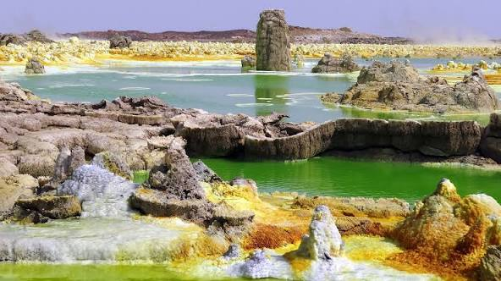
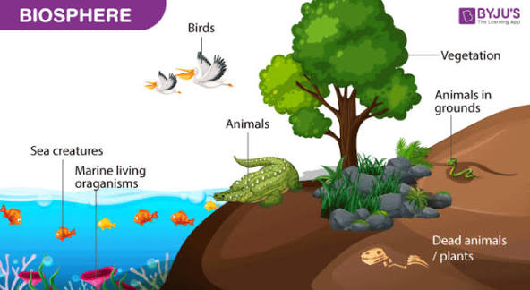
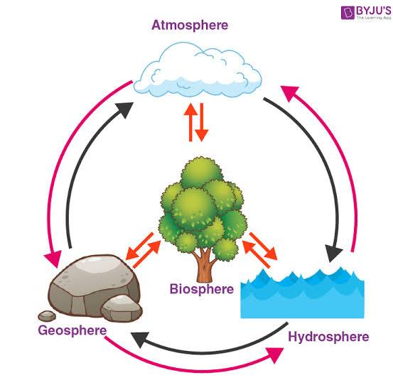
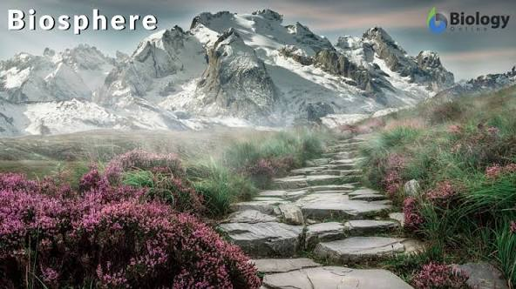
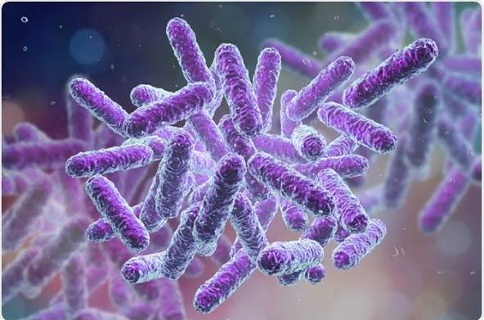
View all
The parts of Earth where life doesn't exist, outside the biosphere, include the deep interior (mantle/core) and extreme upper atmosphere (mesosphere), but scientists recently identified the Dallol Geothermal Field (Ethiopia) as a place with absolutely no life, even microbes, due to its hyperacid, hot, and salty water, making it a prime example of a truly lifeless zone. The biosphere is the zone where life does exist, encompassing all ecosystems.
This video explains the concept of the deep biosphere and its inhabitants:
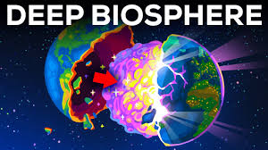
1m


Kurzgesagt – In a Nutshell
YouTube • 3 Oct 2024

Where Life Doesn't Exist (Outside Biosphere):
- Earth's Interior: The mantle and core are too hot and have immense pressure, lacking water and sunlight, making them inhospitable.
- Upper Atmosphere: Layers like the mesosphere lack matter and water for life.
- Extreme Environments (Recently Discovered):
  - Dallol Geothermal Field: This Ethiopian site has hot, hyperacid, salty ponds where no microbial life can survive, making it the world's most uninhabitable spot.
  - Pure Oil: In deep oil wells, life struggles in pure oil, though it thrives where water mixes in.
You can see another video about the shadow biosphere, which explores life in extreme environments:
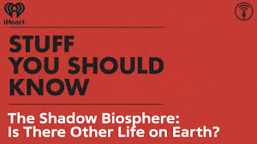
53s


Stuff You Should Know
YouTube • 2 Oct 2024

What is the Biosphere?
- It's the global ecological system integrating all living beings and their relationships, including the air (atmosphere), water (hydrosphere), and land (lithosphere).
The key takeaway: The biosphere is where life exists; places without life, like deep underground or the Dallol ponds, are outside the biosphere's habitable limit

✅ अगर पृथ्वी के किसी हिस्से में जीवन नहीं है, तो वह Biosphere का हिस्सा नहीं होता।

उदाहरण:
✔ गहरे मेंटल (Mantle) – यहाँ जीवन नहीं → Biosphere का हिस्सा नहीं
✔ ऊपरी Troposphere तक जीवन मिलता है
But Stratosphere, Mesosphere में लगभग जीवन नहीं → वो Biosphere नहीं
✔ बहुत गर्म ज्वालामुखी का लावा → जीवन नहीं → Biosphere नहीं
✔ समुद्र की बहुत गहरी जगहें (जहाँ life है) → Biosphere का हिस्सा
लेकिन जहाँ life नहीं → Biosphere का हिस्सा नहीं
✔ अंटार्कटिका की बर्फ में जहाँ life है → Biosphere
लेकिन जहाँ कोई microbe भी नहीं → Biosphere नहीं

⭐ सरल भाषा में
Biosphere = पृथ्वी के वही हिस्से जहाँ किसी भी रूप में जीवन पाया जाता है।
जहाँ life नहीं है, वो Biosphere नहीं।

🌍 Biosphere कितनी ऊँचाई और कितनी गहराई तक फैला है?

1️⃣ ऊँचाई (Upward extent of Biosphere)
Biosphere लगभग 8–10 km ऊँचाई तक फैला है (Troposphere तक), क्योंकि यहीं तक—
- पक्षी उड़ सकते हैं
- बैक्टीरिया वाइंड से ऊपर जा सकते हैं
- तापमान जीवन के लिए अनुकूल होता है
➡ Stratosphere, Mesosphere में जीवन लगभग नहीं मिलता, इसलिए वे Biosphere का हिस्सा नहीं माने जाते।

2️⃣ गहराई (Downward extent of Biosphere)
Biosphere समुद्र में लगभग 6–11 km गहराई तक पाया जाता है, जहाँ deep-sea microbes और कुछ जीव पाए जाते हैं।
भूमि के अंदर life:
- मिट्टी में कुछ km (लगभग 3–5 km) नीचे तक micro-organisms मिलते हैं।
- इसके आगे बहुत गर्मी और दबाव के कारण life नहीं → Biosphere नहीं।

⭐ UPSC-ready एक लाइन
Biosphere पृथ्वी की सतह से लगभग 10 km ऊपर तक और 10–11 km गहराई तक फैला है — जहां-जहां जीवन संभव है।

Google
The biosphere is the global sum of all ecosystems, representing the thin layer on Earth where life exists, interacting with land (lithosphere), water (hydrosphere), and air (atmosphere) to support all living organisms, from microbes to humans, encompassing all terrestrial, aquatic, and atmospheric environments where life thrives. It's essentially Earth's "zone of life," a closed system for matter, vital for biodiversity, energy cycles (like photosynthesis), and includes biomes such as forests, deserts, and oceans.
Key aspects of the biosphere:
- Definition:
The global ecological system integrating all living beings and their relationships, including their interactions with the physical environment.
- Components:
Includes all ecosystems, biomes (like rainforests, tundras), and the interconnected life forms within them (plants, animals, bacteria).
- Interactions:
Life in the biosphere depends on the interplay between the atmosphere (air), hydrosphere (water), and lithosphere (land).
- Energy Flow:
Driven primarily by solar energy, with photosynthesis by producers (plants, algae) forming the base of energy chains that feed consumers (herbivores, carnivores, omnivores).
- Scope:
Extends from deep ocean trenches to the lower atmosphere, a narrow band essential for Earth's habitability.
Significance:
- It's the source of all life and biodiversity on Earth.
- Its health is crucial for human survival, requiring sustainable practices to protect its ecosystems, like rainforests and mangroves.

Biosphere Definition
The biosphere, which includes the ground and the air, is characterized as the region of the planet where organisms live. The biosphere is defined as the region on, above, and below the Earth’s surface where life exists.
The biosphere is a narrow zone on the surface of the earth where soil, water, and air combine to sustain life. Life can only occur in this zone. From fungi and bacteria to large animals, there are several different types of life.
The biosphere is characterized as an area that contains all living organisms and the products of their activities. As a result, it plays a critical role in the maintenance of ecosystems, i.e., the existence of species and their reciprocal interactions. And the biosphere is critical for climate regulation.
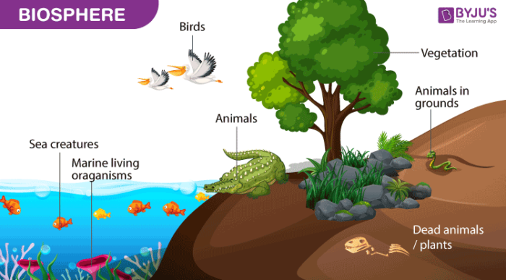

Biosphere Resources
The biosphere provides important resources. Many people rely on the biosphere for basic necessities including food, medicine, construction materials, and fuel. Indigenous peoples, in particular. Except for salt, all food comes from the biosphere, but established societies prefer to farm rather than forage.
The biosphere is a relatively thin layer of the Earth’s surface that supports life, reaching from a few kilometers into the atmosphere to deep-sea vents. The biosphere is a global ecosystem made up of living organisms (biota) and the nonliving (abiotic) factors that provide them with energy and nutrients.
The biosphere is a narrow zone on the surface of the earth where soil, water, and air combine to sustain life. Life can only occur in this zone. From fungi and bacteria to large animals, there are several different types of life.
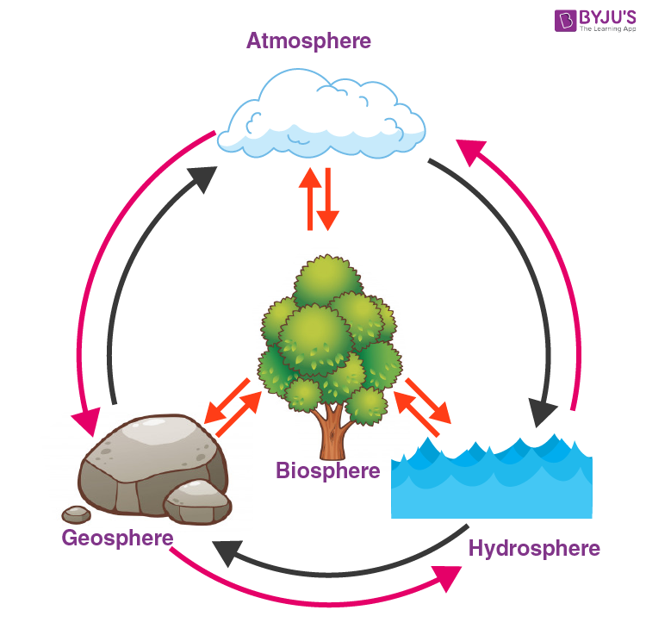

Importance of Biosphere
The biosphere provides the ecosystem that is needed for survival. Adaptation to the biosphere’s climate is expected for living organisms. Biodiversity thrives within ecosystems, and the biosphere is a reliable source of food on Earth. Biodiversity is just what it sounds like biological variety.
Safe areas for the protection of plants and animals are known as biosphere reserves. It also helps to restore the tribals’ traditional way of life in the region. They protect the region’s biodiversity. The biosphere is the ecological organization’s highest level. It covers all types of life as well as any biome on the earth.
The biosphere functions as the planet’s life support system, assisting in the control of atmospheric composition, soil health, and the hydrological (water) cycle. A indicator of a biome’s contribution to the earth. The biosphere is a narrow zone on the surface of the earth where soil, water, and air combine to sustain life. Life can only occur in this zone.

Biosphere Facts
- The biosphere is related to the lithosphere, hydrosphere, and atmosphere, which are all spheres of the physical world. The lithosphere is the Earth’s solid outer layer, which contains rocks, sand, and soil.
- The biosphere is characterized as an environment that contains all living organisms and the products of their activities. As a result, it plays a vital role in the conservation of ecosystems, i.e., the life of species and their reciprocal interactions. And the biosphere is critical for climate regulation.
- Any of the main greenhouse gases, such as methane, carbon dioxide, and nitrous oxide, are affected by the biosphere.
- Various environmental conditions, such as favorable temperature and moisture, are needed for organisms to live on Earth. Energy and nutrients are also needed by the species. The biosphere of the Earth contains all of the mineral and animal nutrients needed for life.

Biosphere Examples
The biosphere, which includes the ground and the air, is characterized as the region of the planet where organisms live. The biosphere is defined as the region on, above, and below the Earth’s surface where life exists. The part of the world where life naturally exists, spreading from the deep crust to the lower atmosphere.
The biosphere, also known as the ecosphere, is the Earth’s dynamic biological epidermis of unknown dimensions. It is the natural habitat of living organisms. It is made up of the lithosphere’s surface, a lower portion of the atmosphere, and the hydrosphere.
The biosphere is the world’s ecological system as a whole. It encompasses all forms of life on Earth as well as all habitats capable of sustaining life. There are many biomes that make up the biosphere. These areas have unique climates, vegetation, wildlife, and adaptations that must be met in order to live.
Photosynthesis is the main source of energy for ecosystem processes. Processes in the biosphere are intertwined with those in the atmosphere, hydrosphere, and geosphere. Via the balance of photosynthesis and respiration, biological processes play a significant role in controlling atmospheric CO₂ concentrations.

Frequently Asked Questions – FAQs
Q1

What are the Biosphere and its types?
The biosphere is the region of the Earth where life can be found, including the soil, water, and air. The lithosphere, hydrosphere, and atmosphere are the names for these three components. The lithosphere is the landmass of the Earth, except for the mantle and core, which are inhospitable to life.
Q2

What are the 4 components of the biosphere?
“Spheres” refers to these four subsystems. The “lithosphere” (land), “hydrosphere” (water), “biosphere” (living things), and “atmosphere” (air) are the four spheres (air).
Q3

What are the benefits of the biosphere?
By promoting the wise use of natural and human resources, biosphere reserves contribute to the region’s environmental, economic, and social sustainability. They provide practical solutions for resolving land use disputes and safeguarding biological diversity.
Q4

How does the biosphere affect humans?
People play a critical role in sustaining the biosphere’s energy flow. People, on the other hand, may often stifle the flow. When people clear forests or burn fossil fuels like coal and oil, for example, oxygen levels in the atmosphere drop and carbon dioxide levels rise.
Q5

What factors affect the biosphere?
Life would not have been able to live in these too hot or too cold conditions. Climate, humidity, precipitation, temperature, erosion, and other minor factors alter the land and living conditions around living species. These elements have the ability to have an effect at the molecular level.

📌 Difference between Biosphere and Biosphere Reserve
Biosphere | Biosphere Reserve
यह पूरी पृथ्वी पर जीवन का क्षेत्र है। | यह एक चुना हुआ बड़ा संरक्षित क्षेत्र है जहाँ जैव विविधता को बचाया जाता है।
प्राकृतिक रूप से मौजूद। | सरकार/UNESCO द्वारा घोषित किया जाता है।
इसमें भूमि, जल, वायु—सब शामिल। | इसमें Core, Buffer, Transition जैसे 3 संरक्षण zones होते हैं।
इसका कोई संख्या सीमित नहीं—यह वैश्विक है। | भारत में 18, दुनिया में 700+ Biosphere Reserves हैं।
Biosphere = Global level | Biosphere Reserve = Local/Regional level
यह सभी ecosystems का योग है। | यह एक खास ecosystem या कई ecosystems को सुरक्षित करता है।
इसका उद्देश्य: जीवन को बनाए रखना। | उद्देश्य: संरक्षण (Conservation) + विकास (Development)

📌 आसान भाषा में अंतर
- Biosphere = जहाँ भी पृथ्वी पर जीवन है।
- Biosphere Reserve = वह विशेष क्षेत्र जिसे सरकार/UNESCO ने सुरक्षित बनाया है ताकि वन्यजीव और प्रकृति बचे रहें।
Biosphere प्राकृतिक रूप से पृथ्वी का जीवन क्षेत्र है,
जबकि Biosphere Reserve मानव द्वारा बनाया गया संरक्षित क्षेत्र है।
Bottom of Form

🟦 UPSC Tough Level MCQs — Biosphere

1. Which one of the following best describes the Biosphere?
A. All living organisms on Earth only
B. All regions where life exists on Earth
C. Only terrestrial ecosystems
D. Only atmospheric part where life exists
✔ Correct Answer: B
Explanation: Biosphere = land + water + air जहाँ life हो सके।

2. In the context of Biosphere, consider the following statements:
- Biosphere includes all ecosystems present on Earth.
- Biosphere includes only the living components, not the non-living.
- Biosphere extends into both lithosphere and hydrosphere.
Which of the statements is/are correct?
A. 1 and 3 only
B. 1 only
C. 2 and 3 only
D. All 1, 2 and 3
✔ Correct Answer: A
Statement 2 गलत — Biosphere में living + non-living interactions शामिल होते हैं।

3. The upper and lower limits of the Biosphere are mainly controlled by:
A. Solar radiation and rainfall
B. Temperature and pressure conditions
C. Cloud formation
D. Soil fertility
✔ Correct Answer: B
Life की ऊपरी-निचली सीमाएँ temperature और pressure तय करते हैं।

4. Which of the following is not a component of the Biosphere?
A. Deep ocean hydrothermal vent ecosystem
B. Lichen community on bare rocks
C. Troposphere up to 10 km
D. Lower mantle region
✔ Correct Answer: D
Lower mantle में life नहीं → Biosphere का हिस्सा नहीं।

5. Consider the following:
- Photosynthesis
- Nitrogen fixation
- Plate tectonics
- Decomposition
Which contribute to the functioning of the Biosphere?
A. 1, 2, and 4
B. 1 and 3 only
C. 2 and 3 only
D. All 1, 2, 3, and 4
✔ Correct Answer: A
Plate tectonics जीवन की प्रक्रिया नहीं है। अन्य तीन biosphere processes हैं।

6. The Biosphere depends directly on which of the following layers for the supply of energy?
A. Lithosphere
B. Hydrosphere
C. Atmosphere
D. Sunlight from space
✔ Correct Answer: D
Biosphere की ऊर्जा का मूल स्रोत Sun है।

7. Life in the Biosphere is absent beyond a certain altitude mainly because:
A. Gravity becomes zero
B. UV radiation increases and oxygen decreases
C. Cloud formation obstructs life
D. Temperature becomes extremely hot
✔ Correct Answer: B
ऊँचाई बढ़ने पर temperature कम, oxygen कम और UV radiation ज़्यादा → life difficult।

8. Which of the following statements about Biosphere is correct?
A. It has well-defined fixed boundaries.
B. It includes only the regions above sea level.
C. It is a global ecological system integrating all living beings.
D. It excludes microorganisms living underground.
✔ Correct Answer: C

9. “No life exists beyond certain depth in the ocean.” This limit is primarily due to:
A. Lack of sunlight
B. High pressure and temperature
C. Salinity
D. Movement of water currents
✔ Correct Answer: B
Deep levels में pressure + temperature life-limit तय करते हैं।

10. Which of the following interactions define the functioning of the Biosphere?
- Biotic–Biotic
- Biotic–Abiotic
- Abiotic–Abiotic
A. 1 only
B. 1 and 2 only
C. 1, 2 and 3
D. 2 and 3 only
✔ Correct Answer: C
Biosphere = सभी प्रकार की interactions।

1. With reference to the Biosphere, consider the following statements:
- The Biosphere includes all parts of the atmosphere where ozone concentration is maximum.
- Biosphere does not include the regions where heterotrophic life is absent.
- Biosphere boundary varies with latitude and season.
Which of the statements is/are correct?
A. 3 only
B. 1 and 2 only
C. 2 and 3 only
D. 1, 2 and 3
✔ Correct Answer: C
Statement 1 गलत—Ozone layer Stratosphere में है, वहाँ life नहीं → Biosphere नहीं।

2. The presence of life in the deep ocean trenches is limited mainly because:
A. Absence of minerals
B. High density of water
C. Extreme hydrostatic pressure
D. Absence of organic matter
✔ Correct Answer: C

3. In the Earth's Biosphere, the vertical distribution of life in the atmosphere is restricted to lower layers mainly due to:
A. Rapid fall in pressure
B. Absence of CO₂
C. High UV radiation
D. Decrease in oxygen
Select the correct answer using the code below:
A. 1, 3 and 4
B. 1 and 3 only
C. 2 and 4 only
D. 3 only
✔ Correct Answer: A
सभी factors life को limit करते हैं।

4. Which one of the following best explains why Biosphere is considered a ‘global ecological system’?
A. It includes the Alluvial plains and shallow seas.
B. It integrates all organisms and their interactions with abiotic components.
C. It includes only productive ecosystems.
D. It supports life only on land and shallow water.
✔ Correct Answer: B

5. In the Biosphere, which of the following cycles forms the basis of material exchange?
- Biogeochemical cycles
- Tectonic cycles
- Hydrological cycles
A. 1 and 3 only
B. 1 only
C. 2 and 3 only
D. 1, 2 and 3
✔ Correct Answer: A
Tectonic cycle Biosphere process नहीं है।

6. The term “Gaia Hypothesis” is most closely related to which concept?
A. Plate tectonics modifies the Biosphere
B. Biosphere self-regulates life-supporting conditions
C. Biosphere expands continuously with evolution
D. Earth’s crust forms the Biosphere
✔ Correct Answer: B
Gaia = Earth acting as a self-regulating system.

7. Which of the following best describes the lower boundary of Biosphere on land?
A. Depth where organic matter is absent
B. Point where temperature exceeds tolerance of microbial life
C. Depth where soil porosity becomes zero
D. Depth where sunlight cannot reach
✔ Correct Answer: B

8. Which process controls the upper boundary of the Biosphere in the atmosphere?
A. Formation of clouds
B. Decrease in UV radiation
C. Availability of water vapour
D. Decline in air pressure and temperature
✔ Correct Answer: D

9. Why is Biosphere called an “open system” for energy but “closed system” for matter?
A. Energy enters and leaves Earth; matter circulates within Earth
B. Both energy and matter enter from outside
C. Neither energy nor matter transfer occurs
D. Only matter enters Earth, energy is constant
✔ Correct Answer: A

10. Consider the following statements:
- Biosphere is absent in the permafrost region.
- Biosphere includes all zones of the ocean.
- Biosphere is the sum total of all ecosystems.
Which of the above statements are correct?
A. 3 only
B. 2 and 3 only
C. 1, 2 and 3
D. 1 and 3 only
✔ Correct Answer: D
Statement 2 गलत — ocean के “सभी” zones में life नहीं मिलता (abyss में कई जगह no-life zones)।

🟩 UPSC PYQs – BIOPSHERE (with Answers)

1) UPSC Prelims 2014
The term “Biosphere Reserve” means:
A. A protected area for all forms of life
B. A reserved forest area
C. A national park
D. A world heritage site
✔ Answer: A

2) UPSC Prelims 2018
In India, the concept of “Biosphere Reserve” was introduced to protect:
- Biodiversity
- Genetic resources
- Ecological integrity
Select the correct answer:
A. 1 only
B. 1 and 2 only
C. 1, 2 and 3
D. 2 and 3 only
✔ Answer: C

3) UPSC Prelims 2020
Which one of the following statements best explains “Biosphere”?
A. It is a region containing all living organisms
B. It is a narrow zone where land, water and air interact
C. It is the global ecosystem involving all living beings and their relationships
D. It is the sphere around earth where ozone concentration is maximum
✔ Answer: C

4) UPSC Prelims 2012
Which of the following is/are included in the Biosphere?
- Hydrosphere
- Lithosphere
- Atmosphere
A. 1 and 2 only
B. 2 and 3 only
C. 1 and 3 only
D. 1, 2 and 3
✔ Answer: D

5) UPSC Prelims 2016
Consider the following:
- Decomposition
- Energy flow
- Nutrient cycling
Which of the above are essential processes for functioning of the Biosphere?
A. 1 and 2 only
B. 2 only
C. 1, 2 and 3
D. 1 and 3 only
✔ Answer: C

6) UPSC Prelims 2017 (Matched to Biosphere concept)
Which of the following best explains “Ecotone”?
A. Region of transition between two ecosystems
B. Region where life does not exist
C. A part of the biosphere that is isolated
D. Area of uniform climate
✔ Answer: A

7) UPSC Prelims 2019
With reference to India’s Biosphere Reserves, which of the following statements is correct?
A. All biosphere reserves are part of UNESCO-MAB programme
B. Some are part of UNESCO-MAB programme
C. No biosphere reserve is globally recognised
D. All biosphere reserves are located in the Himalayas
✔ Answer: B

8) UPSC Prelims 2015
Which of the following are not components of the Biosphere?
A. Non-living matter
B. Living organisms
C. Energy
D. Weather cycles
✔ Answer: D
(Weather is part of atmosphere, but biosphere ≠ atmosphere)

9) UPSC Prelims 2021
The productivity of the Biosphere is highest in which ecosystem?
A. Desert
B. Tropical rainforest
C. Tundra
D. Grassland
✔ Answer: B

10) UPSC Prelims 2013
Which one of the following processes is NOT included in the functioning of the Biosphere?
A. Photosynthesis
B. Decomposition
C. Weathering of rocks
D. Nutrient cycling
✔ Answer: C

